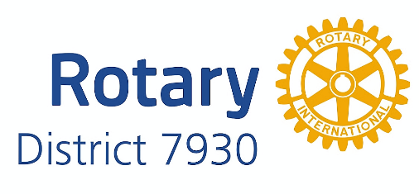


Polar Plunge Sponsorship Form

Please complete the form and return to:
Rotary District 7930 * Attention: Robert C. Wood, Treasurer
11 Rainbow Ridge Way, Georgetown, MA 01833
Please make checks payable to: Rotary District 7930

Please print clearly.

Organization Name Mailing Address

Contact Person Contact Phone Contact Email
We would rather pay by credit card. Our credit card information including address and security number is on the back.

Please select your sponsorship level
Life Saver | $1000 or more
Freezin’ for a Reason Sponsor | $500
Polio Champion Sponsor | $250
Gift of Life Sponsor | $100

Deadline for T-Shirt Inclusion is January 05, 2016
Questions? Contact us at bobcwood@verizon.net.

