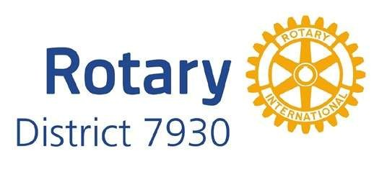
Rotary District 7930

2025-2026 Public Image Mini-Grant

Overview
- The grant is a reimbursement matching grant for 50% of expenses to a maximum payment of $250.
- Clubs cannot receive grant money up front but may submit receipts for payment prior to the deadline. Mini-grant funds may be used to subsidize a larger quote.
- All promotions, materials, and messaging must meet the Rotary International Branding
Standards and PRE-APPROVED by a member of the Public Image Committee. Design help is available from the Public Image Committee.
- Qualifying materials/promotions/messaging may be used to promote projects, membership, events, or general information but should be primarily aimed at increasing the visibility of your club and improving its public image.
- Recipients may be asked to share their materials/designs with other Rotary clubs.
- It is highly encouraged that materials/promotions/messaging serve a multi-purpose. For example, materials for an event should include an invitation to visit a club.

REQUIREMENTS
- Your Club must be District 7930 Grant Qualified for the 2025-2026 Rotary year, and the submitter must be Grant Trained as well.
- You must submit a sample of the design proposed for your grant item(s). All designs must match Rotary Branding Guidelines. Grants will not be approved without a pre-approved design.
- Submit a photo of your finished product in action to the Public Image Committee with receipts by or before the deadline.

TIMELINE
December 1, 2025 - grants submission deadline (notice of acceptance or denial by December 21, 2025). Receipts and a photo must be submitted to the Membership Committee for reimbursement by March 31, 2026.

INSTRUCTIONS FOR APPLICANTS
Please complete the following application. Incomplete applications will not be considered. Submit the application along with a sample of your proposed materials to: Rotary District 7930 Membership Mini Grant, c/o Ron Block, 7109 Heather Drive, Lynnfield, MA 01940-4228. Electronic applications are preferred. Please email PDF or Word Doc to ronblock1@verizon.net with PI Mini Grant in the subject line.

CHECKLIST (FOR CLUB USE ONLY)
□ The primary and my partnering (if applicable) club’s Board of Directors know we are applying for this mini-grant and that the club(s) must match each dollar requested.
□ The primary club’s Treasurer understands this is a reimbursement matching grant and must submit a copy of the project’s receipt(s) no later than March 31, 2026.
□ We have read the requirements and understand the timeline.
□ I have submitted the application to the Public Image Committee.
□ I have submitted the required documents for reimbursement by March 31, 2026.
QUESTIONS? Contact o Ron Block, 7109 Heather Drive, Lynnfield, MA 01940-4228, 201-390-5866 or email to ronblock1@verizon.net
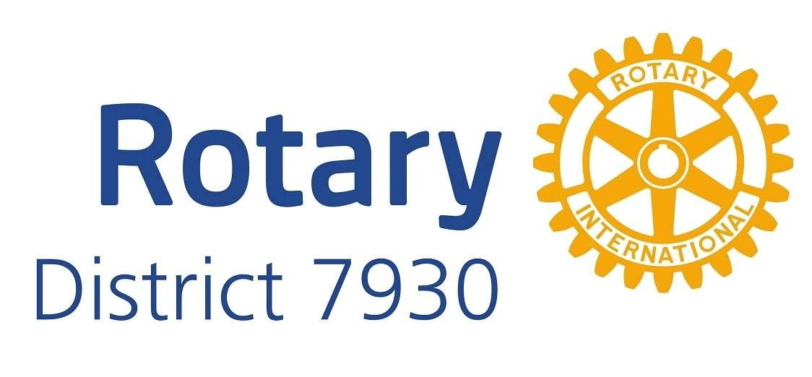
Public Image Mini-Grant

2025-2026 Application
Please type or print clearly.
Primary Rotary Club Name |  |  | Club Public Image Chair Name
Primary Contact | Primary Phone |  |  | Primary Email
Briefly describe what the mini-grant will be used for. Include information such as your reach, quantity and target. What is the goal of the project? Is it measurable (if applicable)?
Select one or more categories your grant will be used for:
❑ club brochure  direct mail  social media advertising
❑ club business cards  event promotions  television advertising
❑ club clothing or nametags  promotional products  website development
❑ club display (multi-use)  professional photography  other(specify)_________
❑ club signage  PSA production
You must submit a copy of your proposed design in advance. It must comply with Rotary Branding
Guidelines. Failure to get pre-approval of your design may result in disqualification of reimbursement.
If purchasing items, will they be:  (check if applicable)   for members’ use   given to the public |  | Proposed vendor name
Total Project Cost  $__________________ |  | Amount Requested  $__________________
By signing below, I acknowledge that my Rotary Club, if awarded, will receive the mini-grant as a reimbursement after I submit the project’s required financial documents to the Public Image Committee by March 31, 2026.
________________________________ |  | ___________________________
Club President’s Signature |  | Date
________________________________ |  | ___________________________
Club President’s Email |  | Club President’s Phone

